26.68: a) Ignoring the capacitor for the moment, the equivalent resistance of the two parallel resistors is
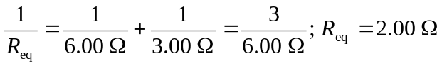
In the absence of the capacitor, the total current in the circuit (the current through the 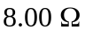 resistor) would be
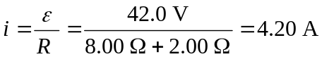
of which 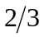, or 2.80 A, would go through the 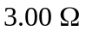 resistor and 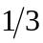, or 1.40 A, would go through the 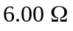 resistor. Since the current through the capacitor is given by
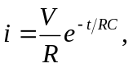
at the instant 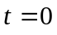 the circuit behaves as through the capacitor were not present, so the currents through the various resistors are as calculated above.
b) Once the capacitor is fully charged, no current flows through that part of the circuit. The and the resistors are now in series, and the current through them is The voltage drop across both the resistor and the capacitor is thus (There is no current through the resistor and so no voltage drop across it.) The change on the capacitor is

